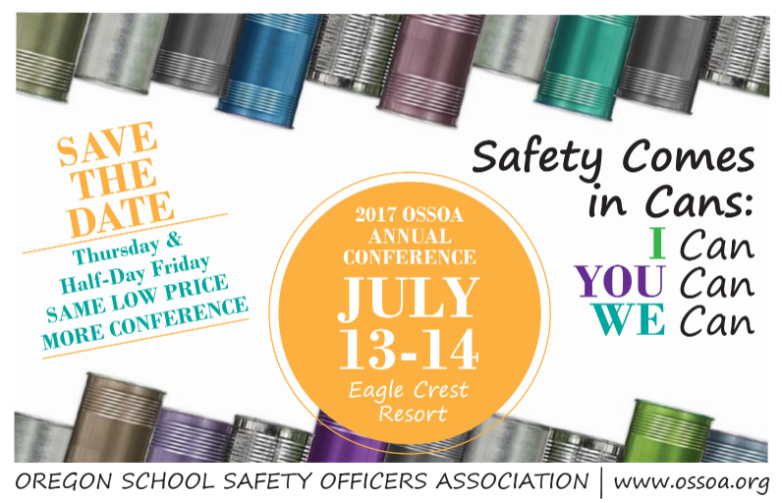

Agenda
Thursday July 13, 2017
8:00-8:30 am Registration
8:00-8:45 am Breakfast
8:30-8:45 am Annual Board meeting
8:45-9:15 am Drones – Geoff Sinclair and Scott Neufeld, SDAO
9:15-10:00 am Role Abandonment w/ Scott Johnson,
10:00-10:15 am Break
10:15-11:00 am Oregon State Tip Line - Jodi Sherwood, Oregon State Police
11:05 am – 12:15 pm Round table Discussions (30 min sessions. Participants choose two)
Round table 1 – OSHA Updates - Corie Stengle, Oregon OSHA
Round table 2 – Ergonomics Cool Tools For Schools, Chris Liechty, SAIF Corp.
Round table 3 – Lead in Drinking Water/Healthy & Safe Schools Plan - Vonnie Good, Salem-Keizer School District, and Kevin Montague, Dallas School District
12:15pm - 1:00 pm Lunch
1:00 - 2:00 pm Employment & Athletic Liability Practices – Kate Wilkinson and Hailey Purcell, PACE
2:00 - 2:15 pm Break with snacks
2:15 - 3:30 pm Transgender - Victoria Nolan, Clean Water Services
3:30 - 4:00 pm Day 1 wrap up and raffle

** Will add in time during the day to introduce each Premier Sponsor

Friday July 14, 2017
8:30 – 9:00 am Breakfast
9:00 – 11:30 am De-Escalation and Mitigation Techniques - Christopher Stoakes
11:30 am - Noon Day 2 wrap up & questions

