Site Social Distancing Log
All personnel entering this building must check in with the Site Social Distancing Coordinator (SSDC).
Additionally, all personnel will answer the following questions.
Daily Self-check
- Have you had close contact with, or do you live with anyone currently ill and diagnosed with COVID-19?
- Are you currently sick?
- Do you have a fever?
If “yes” to any of the above questions, please return home.
If you have answered “no” to these questions, please sign in and proceed into the building.
Self-check if returning to work after being ill.
- Are you well enough to work?
- Are you free of all symptoms and have been so for 72 hours?
- Have you gone 72 hours without fever reducing medications?
- Has it been 7-10 days since symptoms first appeared?
If “no” to any of these questions, please return home.
If “yes” to all these questions above, please answer the following.
Social Distancing: QAM RSK-W041
Please follow these rules:
- Log in and out upon entering and exiting the site
- Go directly to designated location and limit exposure to approved location
- Do not go into other rooms or areas without approval
- Clean contact areas such as desks, chairs, doorknob, or other areas visited before leaving the room
Be sure to practice all social distancing guidelines
- Remain 6 feet apart
- Practice good hygiene
  - Cover cough
  - Wash hands
        - Wear gloves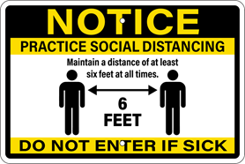
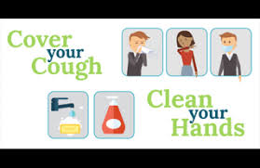
- Staff are encouraged to wear face masks/coverings

Site Name: Lead Site Social Distancing Coordinator Name: Self Check Questions
Name | Date | Destination  Room | Purpose | Q1 | Q2 | Q3 | Time In | Time Out | SSDC Initial

